Leas lift: Restoring Folkestone’s gem for the community
Brief: develop and deliver a touring performance telling the story of Leas Lift
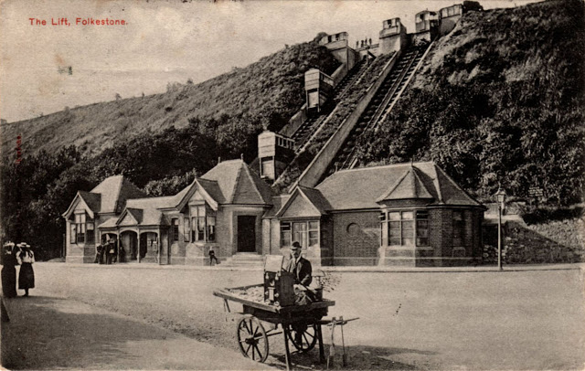

Introduction

Folkestone Leas Lift is a Grade II* (Historic England No. 1061185) cliff funicular railway situated in the Leas & Bayle Conservation Area in Folkestone.
Part of the fabric of Folkestone, it is well loved by the people of Folkestone, many of whom have precious memories of visiting as a child and adult.
This was brought home during public consultation in 2022/23 as part of the project’s Development Phase. Their affection for Leas Lift, and memories were deep and moving when we asked them what they valued about it.
“Very happy memories stretching over nearly 70 years”
“It is part of the story of Folkestone and makes Folkestone what it is”
“It's the town's heritage, it's a beautiful construction, plus being disabled means I can get up to the town quickly and enjoy the views in style!”

During the Development Phase the project’s Interpretation Alix Slater Consultancy & Training Ltd. developed a 3 year Activity Plan in response to public consultation. Now the project is in the delivery phase we are seeking an arts participatory company to develop, deliver and record a touring performance.

The purpose of the performance is to engage children and adults in a fun and engaging way with the history of Leas Lift so that they understand the significance of Leas Lift in the development of Folkestone.

We are expecting a (maximum) 40 minute show of approximately 6 to 10 scenes that tells the story of the Lift’s history, for example how it was constructed, key events, such as the loss of the assistant engineer’s arm in an accident, the Lift during its heyday in Edwardian times, and the lift during wartime.

We have planned for the performance to go on tour to schools during the Autumn 2024 term. This would include Mundella School, Castle Hill School, The Beacon, and St. Eanswythe's School, plus at least two more local schools in Folkestone.
We are expecting the whole school to see the show, using their school halls.

We would also like the show to tour 6 residential homes and day centres during summer 2024 e.g. The Nepalese Centre, Age UK and at least four more day centres and/or residential care homes in Folkestone.

On top of the shows in schools and care homes we would expect three other public performances to be scheduled (venue tbc)

The appointed company will have access to the Conservation Management Plan, Interpretation Plan, Interpretation Designs and a list of objects and research which was compiled by an Archivist in April 2024. We are not expecting them to undertake any additional research.
The appointed company will report to the Community Engagement Coordinators

Outputs are:
- A script
- Production of a set/puppets/costumes/props which must be easily transportable
- Training of actors/puppeteers/performers
- Deliver 15 community performances
- Working in partnership with the Community Engagement Coordinators to
- Pilot the story and approach with at least one school and care home/day centre
- Organise a programme of visits to schools & care homes/day centres

- The design of a simple workshop for schools and community so that participants can create something for, or after the performance. This would be delivered by teachers or the Community Engagement Coordinators.
- The design should include access requirements for both SEND students and those accessing care services. (This may include those that are visually impaired, deaf, hearing loss etc)

The fee is £20,000 plus VAT.

This should include construction of the set/puppets/props, development and testing of the script, 15 performances and a recording of one of the shows.

An invoicing schedule will be agreed on appointment.

If you would like to respond to this tender, in no more than 6 pages, please: •

- Tell us more about your company
- Your experience of working with heritage, history, local schools and communities.
- How you would approach the commission, including testing the content with at least one school and one day centre or care home.
- Explain how you will add social value e.g. offering heritage skills opportunities, local jobs, use of local suppliers.
- Include how you will excel at this project and what it will achieve for the audience and the lift.
- Attach a programme/schedule showing start & end date and how long each stage of the commission will take.
- Attach a breakdown of your budget
- Tell us if you are VAT registered

You can include up to 3 images to support your application.

Your tender will be evaluated on price (20%), experience (20%), quality (50%) and social value (10%)

Timeline

May 10th Application Deadline
May 20th Interview Week
May 27th Decision
June 3rd Performance group commissioned
June -July Research (R&D) and any visits, Script Writing
August Sept- Writing & Rehearsals
Oct -Nov performances

Email tenders to charlotte.chapman@leaslift.co.uk

By 5pm on Friday 10th May.

